**Configure Eclipse IDE with WebDriver**

1. Launch the "eclipse.exe" file inside the "eclipse" folder that we extracted
2. When asked to select for a workspace, just accept the default location or select folder of your choice where you want to keep your project

[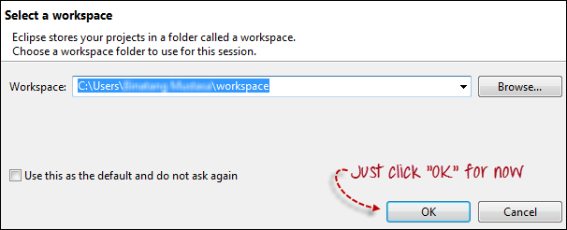](https://www.guru99.com/images/configure_eclipse_1b.png)

3. Create a new project through File > New > Java Project. Name the project as "newproject".

[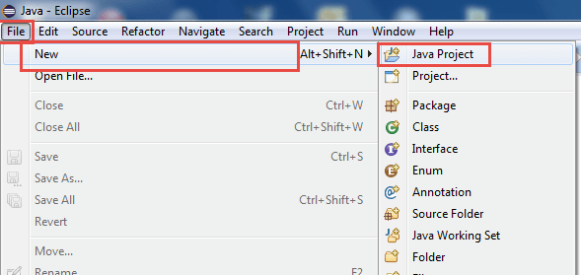](https://www.guru99.com/images/cassandra/021316_1152_SeleniumIns1.png)

A new pop-up window will open enter details as follow

1. Project Name
2. Location to save project
3. Select an execution JRE
4. Select layout project option
5. Click on Finish button

[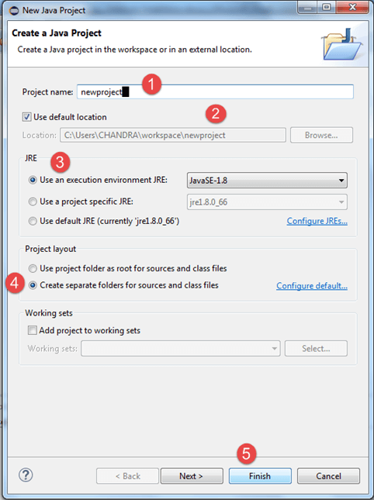](https://www.guru99.com/images/cassandra/021316_1152_SeleniumIns2.png)

4. In this step,

1. Right-click on the newly created project and
2. Select New > Package, and name that package as "newpackage".

[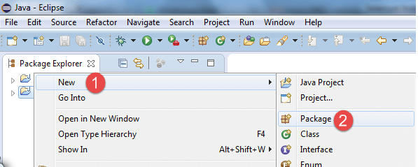](https://www.guru99.com/images/cassandra/021316_1152_SeleniumIns3.png)

A pop-up window will open to name the package,

1. Enter the name of the package
2. Click on Finish button

[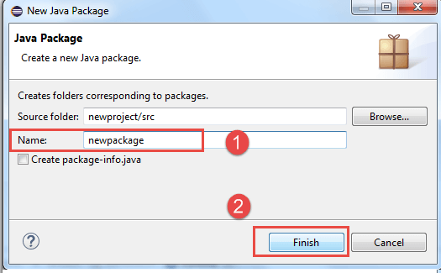](https://www.guru99.com/images/cassandra/021316_1152_SeleniumIns4.png)

5. Create a new Java class under newpackage by right-clicking on it and then selecting- New > Class, and then name it as "MyClass". Your Eclipse IDE should look like the image below.

[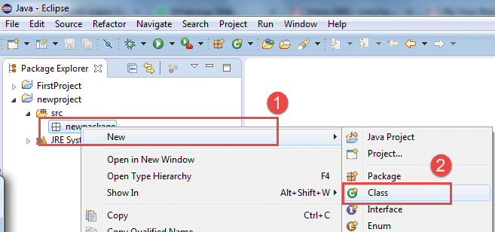](https://www.guru99.com/images/cassandra/021316_1152_SeleniumIns5.png)

When you click on Class, a pop-up window will open, enter details as

1. Name of the class
2. Click on Finish button

[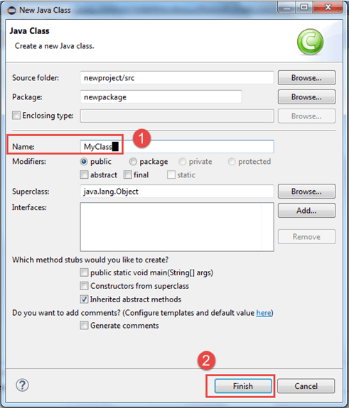](https://www.guru99.com/images/cassandra/021316_1152_SeleniumIns6.png)

This is how it looks like after creating class.

[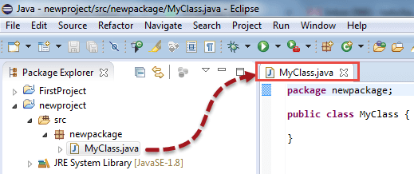](https://www.guru99.com/images/cassandra/021316_1152_SeleniumIns7.png)

Now selenium WebDriver's into Java Build Path

In this step,

1. Right-click on "newproject" and select **Properties**.
2. On the Properties dialog, click on "Java Build Path".
3. Click on the **Libraries** tab, and then
4. Click on "Add External JARs.."

[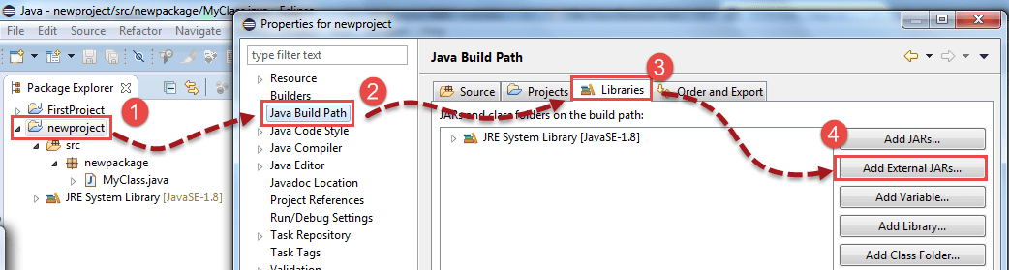](https://www.guru99.com/images/cassandra/021316_1152_SeleniumIns8.png)

When you click on "Add External JARs" It will open a pop-up window. Select the JAR files you want to add.

[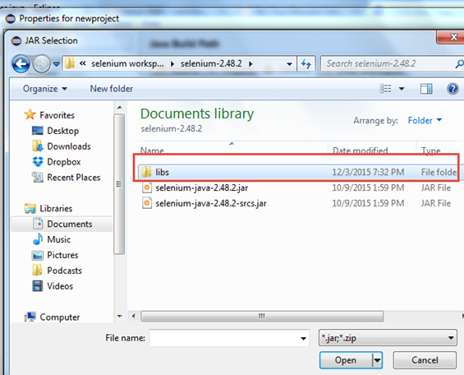](https://www.guru99.com/images/cassandra/021316_1152_SeleniumIns9.png)

After selecting jar files, click on OK button.

Select all files inside the lib folder.

[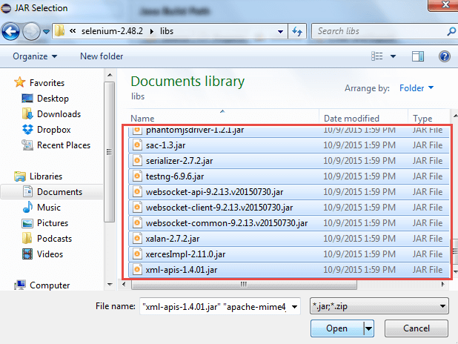](https://www.guru99.com/images/cassandra/021316_1152_SeleniumIns10.png)

Select files outside lib folder

[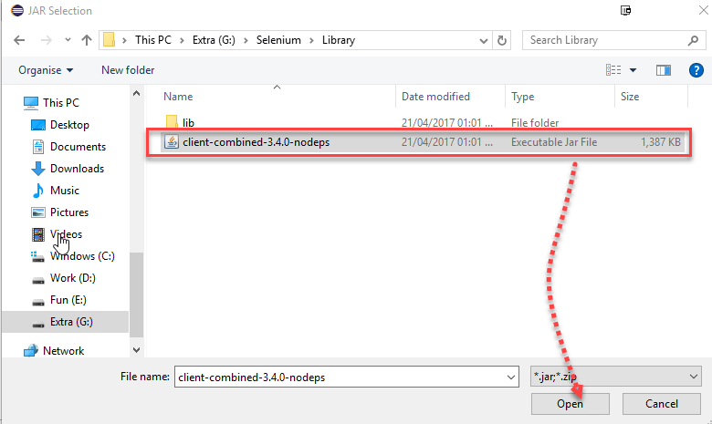](https://www.guru99.com/images/2-2017/022017_1205_Guidetoinst_24_7_2.png)

Once done, click "Apply and Close" button

[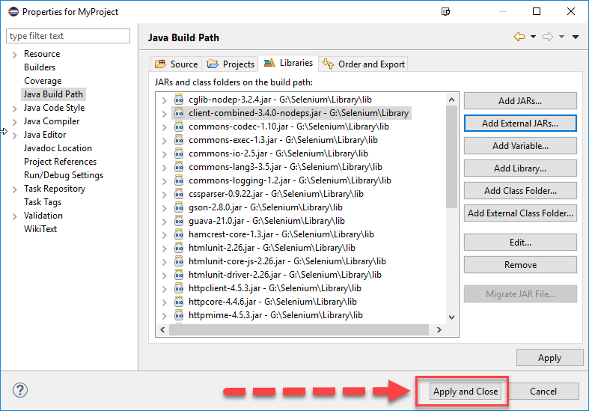](https://www.guru99.com/images/2-2017/022017_1205_Guidetoinst_24_7_3.png)

6. Add all the JAR files inside and outside the "libs" folder. Your Properties dialog should now look similar to the image below.

[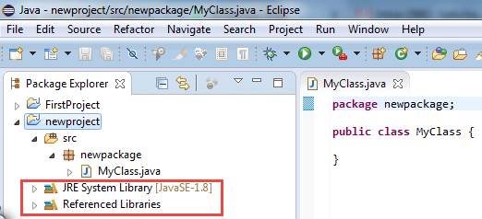](https://www.guru99.com/images/cassandra/021316_1152_SeleniumIns11.png)

7. Finally, click OK and we are done importing Selenium libraries into our project.